**CosmeticBusiness**

**International Supplier Event for the Cosmetics Industry**

**5 – 6 June 2024**

Leipzig, 23 May 2024

**CosmeticBusiness 2024: Where Beauty Starts**

#### Beauty starts with a newly discovered active plant ingredient that reduces wrinkles or makes acne disappear. Beauty also starts with a sustainable dispenser or bottle that helps consumers make ecological purchasing decisions. Ingredients, manufacturing and packaging are all part of the beauty experience. They are "Where Beauty Starts". This is the motto at CosmeticBusiness, where over 400 suppliers from more than 20 countries will present the latest trends and developments in all these areas of the beauty industry from 5 to 6 June 2024 in Munich. We would like to introduce you to some of the new products awaiting trade visitors.

#### All information in the new product information report is based on information provided by the exhibitors. Leipziger Messe is not liable for the functionality and/or safety of the products presented. All photos are supplied by exhibitors and manufacturers and can be used for editorial reporting only in combination with the relevant news item and a reference to the name of the exhibitor.

#### Pictures of the new products presented can be downloaded from the website at

<https://www.cosmetic-business.com/en/media/novelties/>

**Novelties in Ingredients and Manufacturing P. 2 – P. 11**

**Novelties in the Packaging Sector P. 12 – P. 18**

#### Novelties in Ingredients and Manufacturing

#### The idea of harnessing the power of nature to help the skin heal itself is a common feature of the new products in these categories. An important focus is on how recently discovered active plant ingredients and new technologies can be used in cosmetics products.

#### 

**Gaia Tech:**

**Healing the Skin with Upcycled Olives**

Hall 4, Stand F01.8

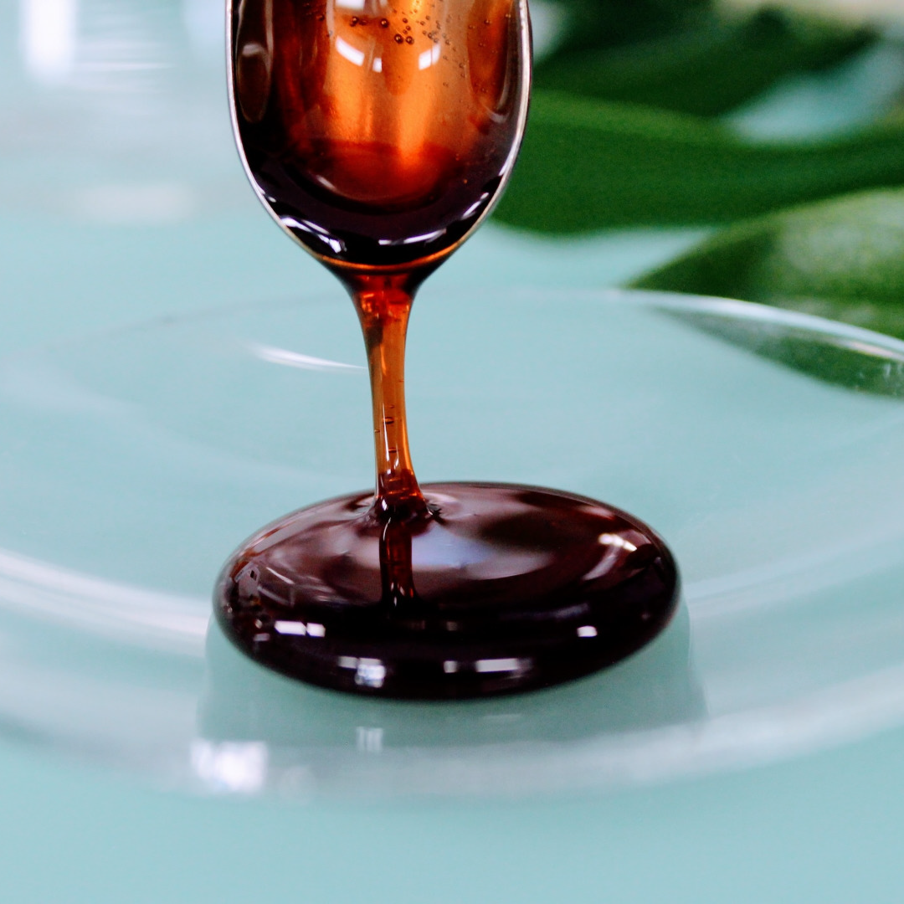

At the trade fair in Munich, the young Swiss company **Gaia Tech** is presenting its antioxidant made from upcycled olives. **Phenoliva Active** is a bioactive extract from olive fruits that is rich in hydroxytyrosols, which are known for promoting a healthy metabolism and regenerating the skin. According to the manufacturer, the extract produces various effects in cosmetics applications, ranging from anti-ageing and UV protection to wound healing and skin lightening. It is suitable for use in products such as anti-ageing creams, sunscreen products, after-sun lotions, lip balms and hand creams.

Web: [www.gaiatech.ch](http://www.gaiatech.ch)

**Helioscience:**

**Corals Affected by Sunscreen Residue**

Hall 2, Stand C21

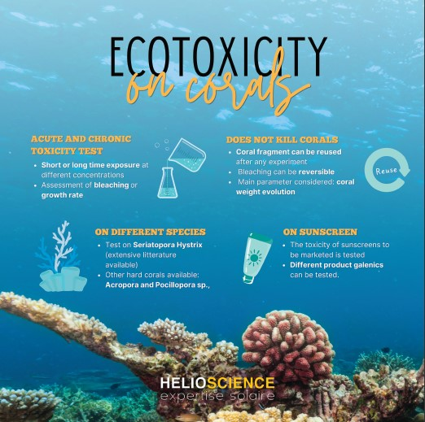

The **Helioscience** test laboratory is presenting an economical and environmentally friendly method of evaluating the effect of cosmetics ingredients on corals. Exposure to UV filters in particular can be severely damaging to reef-building corals. The new method measures the effect of cosmetic formulas on the growth rates of various coral species. The results can then be used to draw conclusions about toxicity. According to the laboratory, the method combines cosmetology, marine biology and ecotoxicology expertise. It allows scientists to carry out robust acute and chronic **toxicity tests** that are economical and do not cause any damage to the corals.

Web: [www.helioscience.org](http://www.helioscience.org)

**KHV Kosmetik:**

**Natural Cosmetics to Improve Skin Affected by Hormonal Imbalance**

Hall 3, Stand A07

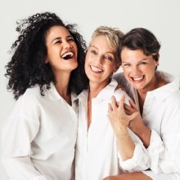

The **MENO Balance** range of natural cosmetics products by manufacturer **KHV Kosmetik** is designed to restore the natural balance of women's skin. The idea behind the product is the fact that women over 35 begin to experience a decrease in oestrogen levels. Oestrogen is responsible for the production of collagen, thus ensuring skin remains firm and radiant. At the same time, progesterone levels can also become unbalanced, and additional hormonal fluctuations can lead to problems with relaxing and sleeping. The manufacturer has launched the new product range aiming to restore the skin's natural balance. It is also intended to help consumers feel good.

Web: [khv-kosmetik.com](https://khv-kosmetik.com/)

**Lignovations:**

**How Plant Biomass Is Used in Cosmetics**

Hall 4, Stand F01.7

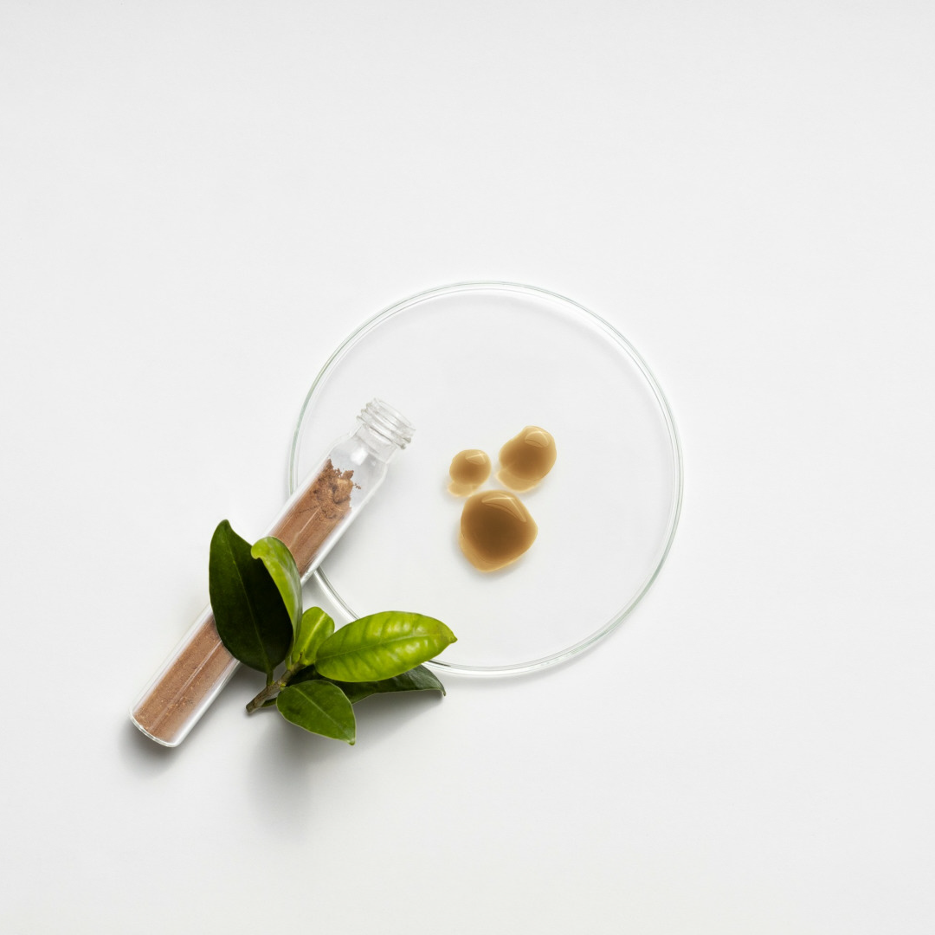

Austrian start-up **Lignovations** is presenting its patented **LignoGuard®** technology to visitors at the trade fair. The technology utilises the natural protective properties of lignin for cosmetics products. Lignin is a central element of plant biomass. The result is a multifunctional ingredient that increases the sun protection factor, provides antioxidant protection and improves emulsion stability. It is compliant with Cosmos, Natrue and Cosmetic-GMP ISO 22716 standards. According to the manufacturer, LignoGuard® can replace synthetic ingredients in a wide range of products including skincare, sunscreen, decorative cosmetics and anti-ageing items.

Web: [lignovations.com](https://lignovations.com)

**maBitec:**

**How Algae Can Reduce Wrinkles and Cellulite**

Hall 2, Stand A08

 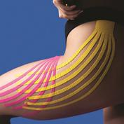

**maBitec**, a specialist in innovative marine ingredients, is presenting its anti-ageing booster called **Algafiller®**. According to the company, the patented ingredient plumps up subcutaneous fatty tissue, reduces wrinkles, increases skin firmness and improves skin tonicity. maBitec is also exhibiting its cellulite eraser **Sealuliss™**. Inspired by the adaptability of marine algae, the active ingredient contains phyllancantha fibrosa, a brown seaweed with molecules that can regulate energy levels. Owing to its lymphotonic activity and anti-inflammatory properties, it can reduce lipid accumulation, improve dermal density and moisturise the skin, the company explains. The substance actively impacts fat cells, reducing fat storage and improving the appearance of cellulite.

Web: [www.mabitec.de](http://www.mabitec.de)

**MC Beauty Science / LipoTrue:**

**A New Era in Cell Elasticity**

Hall 2, Stand D25

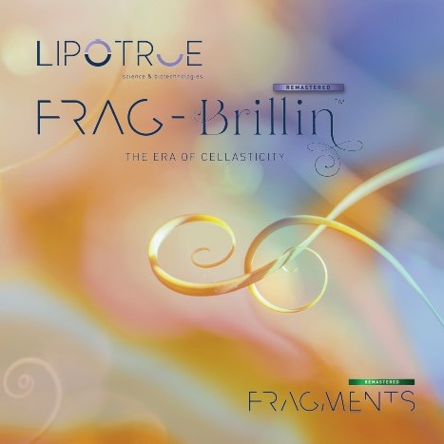

Spanish company **LipoTrue** is attending the trade fair together with distribution partner **MC Beauty Science** to present **Frag-Brillin remastered™**. This is a biomimetic fragment of human fibrillin-1. It is derived from wild plants that are vertically farmed, creating biofactories to express the ingredient. The company explains that the fragment supports the formation of microfibrils and elastic fibres, thus restoring the skin's elasticity. The fragment increases elastic resilience and promotes extracellular matrix remodelling and cell-matrix adhesion. Wrinkles are immediately smoothed away and facial and body skin becomes firmer and more elastic, the exhibitor says.

Web: [lipotrue.com](https://lipotrue.com/) / [www.mcbeauty-science.com](http://www.mcbeauty-science.com/)

**Microphyt:**

**Ocean Power for Healthy, Youthful Facial Skin and Scalp**

Hall 3, Stand D22.1

 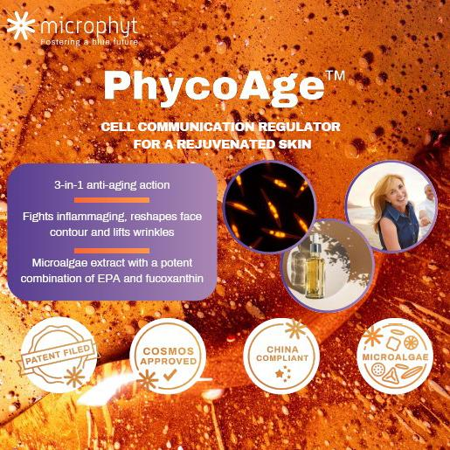

**Microphyt** is a French biotechnology company exhibiting its latest innovation based on microalgae. **Luteana™ scalp** is designed to provide a novel approach to combating dry dandruff. The oil-based bioactive ingredient contains the two marine molecules fucoxanthin and DHA. It addresses biochemical imbalances and strengthens the hydrolipidic film on the scalp, the company reports. Microphyt goes on to explain that **PhycoAge™** is a bio-inspired active ingredient that releases the rejuvenation potential of the microalgae phaeodactylum tricornutum and its marine elements fucoxanthin and EPA. It works on deep layers of the skin by blocking the NF-KB signalling pathways. This results in a 3-in-1 anti-ageing effect that firms and lifts the skin.

Web: [microphyt.eu](https://microphyt.eu)

**NCD Ingredients:**

**Wound-Healing Blend of Microalgae and Watermelon**

Hall 2, Stand A09

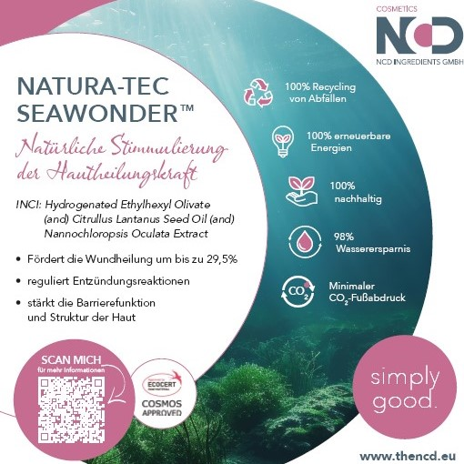

The German trading company **NCD Ingredients** is travelling to Munich to present **Natura-Tec SeaWonder™**, a concentrate derived from the nannochloropsis oculata microalgae mixed with Kalahari watermelon oil. The ingredient features a combination of omega 3, 6 and 9 fatty acids as well as tocopherol, phenolic acids and phytosterols. It regulates inflammatory processes and restores the integrity and function of the skin barrier. According to the company, only small concentrations are needed in a formulation to support the skin, with a 29.5 per cent improvement in wound healing.

Web:[www.thencd.eu](http://www.thencd.eu)

**novoclon:**

**Baobab Skin Training for Increased Durability and Vitality**

Hall 2, Stand B09

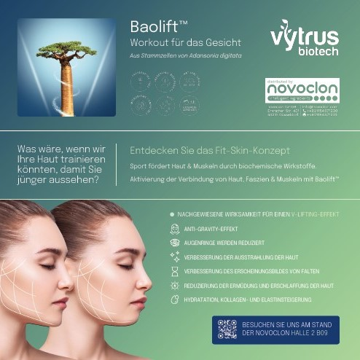

**Baolift™**is a new active ingredient presented by **novoclon**. It is derived from baobab stem cells and activates the connection between skin, fascia and muscles. The company explains that this creates an innovative biological communication network. The active ingredient acts as a plant-based training factor, increasing the skin's durability and vitality and providing anti-gravity and V-lift effects as well as reducing rings under the eyes, the company says.

Web: [novoclon.com](https://novoclon.com)

**Polyneo:**

**Functional Blends Are a New Trend in the Cosmetics Industry**

Hall 4, Stand F01.5



Start-up **Polyneo** is coming to CosmeticBusiness to present its **Cosactive** concept for functional mixtures. Ingredients are selected to function perfectly in harmony with each other. Each is effective on its own, while also interacting with the others to provide a multifunctional effect in the mixture. According to the company, this provides a solution for some common challenges when creating cosmetics formulations, such as optimising stability and viscosity. Furthermore, Cosactive reduces costs and saves time in the development phase. The company has a growing portfolio based on trending topics such as sustainability and vegan cosmetics.

Web: [www.polyneo.eu](http://www.polyneo.eu/)

**Provital:**

**Plant Substances to Combat Collagen Degradation**

Hall 3, Stand E14

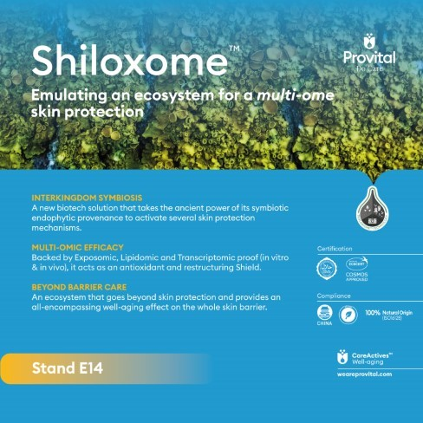

**Provital** is celebrating a product premiere at the trade fair with its active ingredient **Shiloxome™**. It is the first ingredient ever developed using the Triplobiome™ biotech platform, which uses plant-based endophytes to manufacture active ingredients. Endophytes are microorganisms that are able to synthesise bioactive phytochemicals. Substances from the endophytic extract of K. mangroviensis have antimicrobial and antioxidant properties and can also inhibit collagen degradation. The exhibitor explains that Shiloxome™ not only provides protection from environmental pollution, but also strengthens the microbiome barrier and the integrity of the lipid barrier to ensure the epidermis can function as efficiently as possible.

Web: [www.weareprovital.com](http://www.weareprovital.com)

**Sederma:**

**Organic Active Ingredients Combat Signs of Ageing**

Hall 2, Stand D11

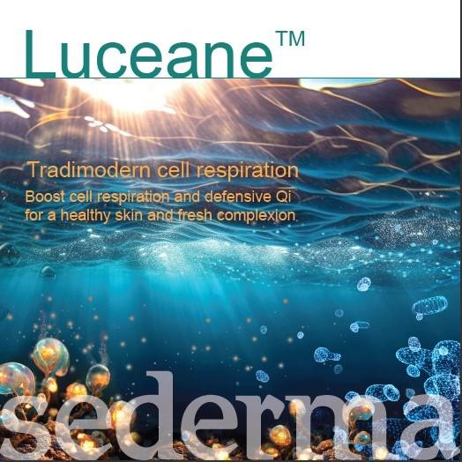 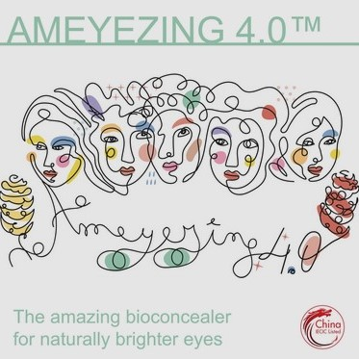

**Sederma** is a member of the Croda Group and is attending the trade show to present its new active ingredients to combat signs of ageing. **LUCEANE™** is an extract obtained by biofermentation of a pseudoalteromonas strain. It is rich in oligosaccharides and can stimulate cellular respiration and energy production. The manufacturer explains that the ingredient also protects the mitochondria from damage caused by air pollutants and promotes the production of ceramides. **AMEYEZING 4.0™** is an extract of Zingiber zerumbet, a herb of the ginger family. According to the company, the active ingredient can reduce hyperpigmentation and vascular dark circles under the eyes. It inhibits melanin overproduction and counteracts oxidative and inflammatory stress. AMEYEZING 4.0™ is approved by COSMOS and complies with China's cosmetics regulations.

Web: www.crodabeauty.com

**Seppic:**

**Improving on Tried and Tested Products**

Hall 2, Stand B12

 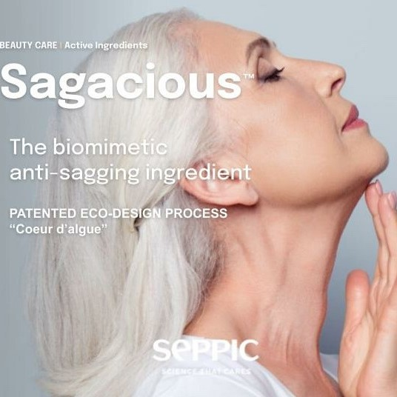

The manufacturer **Seppic** is introducing **Solagum™ GM**, a natural polymer with thickening and moisturising properties. The company explains that only 1 per cent is needed to achieve 10 times higher viscosity than with xanthan gum. By adding 0.5 per cent to gels and emulsions, the ingredient can have a moisturising effect for up to 24 hours. Seppic is also presenting **Sagacious™**, a biomimetic active ingredient against skin sagging. It was inspired by the behaviour of plants in outer space. The active ingredient contains glycolipid molecules from Himanthalia elongata algae. The extract was made using a patented process that can be completed using only half the number of steps usually needed in standard methods.

Web: [www.seppic.com](http://www.seppic.com)

**SLI Chemicals:**

**Plant Power for Multifunctional Formulations**

Hall 2, Stand B14

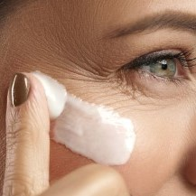 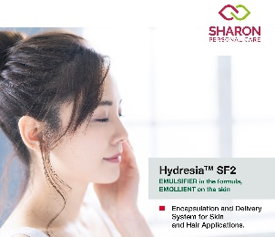

Trading company **SLI Chemicals** is attending the trade fair with two innovations created by its distribution partners. The plant extract **Botaniplex™ CALM 4** is supplied by **Green Mountain Biotech** who say it inhibits MMP-1 collagen degradation and helps to maintain skin structure. When between 1 and 4 per cent is added to products such as anti-ageing and after-sun care, it can provide moisturisation, prevent pigmentation and reduce wrinkles and skin reddening. The second innovation is **HYDRESIA™ SF2** by **Sharon**. It is an emulsifier based on oleosomes. These are plant-based intracellular microcarriers that contain oil and consist of oleosin proteins. These multifunctional carrier systems allow for cold emulsification, for example.

Web: [www.slichemicals.com](http://www.slichemicals.com)

**Summit Cosmetics Europe:**

**New Collagens for Healthy Skin and Hair**

Hall 2, Stand D01

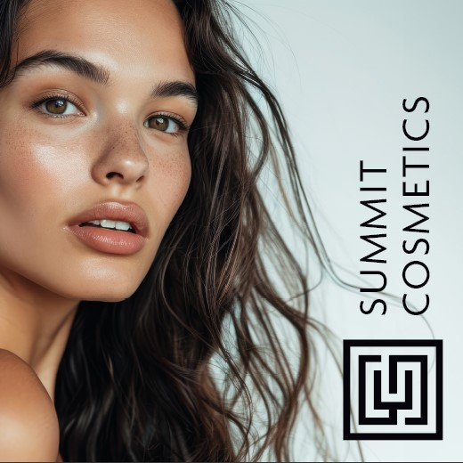

French cosmetics manufacturer **Summit Cosmetics Europe** is presenting two new collagens in Munich. **MINI-RECOL™** is a 5 kDa recombinant type III collagen with active fragments in the amino acid sequence of human collagen. According to the company, it facilitates deep hydration, repairs the skin barrier and tightens the skin. **SRHC TYPE XVII** is a 26 kDa recombinant type XVII collagen that improves the amino acid sequence of human collagen. It can combat hair loss by stimulating hair follicle stem cells and supporting metabolic processes in the hair follicles.

Web: [www.summitcosmetics-europe.com](http://www.summitcosmetics-europe.com)

**Novelties in the Packaging Sector**

#### Sustainability remains the main issue in this sector. Above all, exhibitors at this year's event are expected to demonstrate how they use mono-material solutions to facilitate recycling and support the circular economy. Various exhibits at the trade fair are testimony to the continuing improvements in the use of recycled PCR materials.

**Albéa:**

**Octagonal and Lightweight**

Hall 2, Stand D04

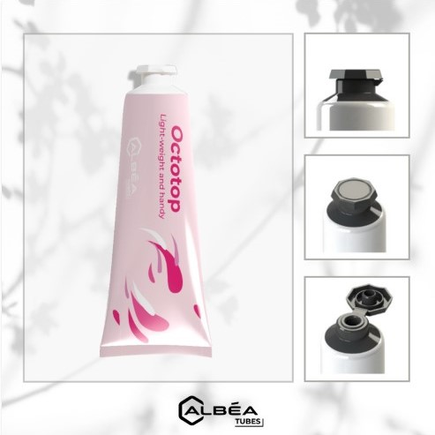

**Albéa** has extended its family of EcoTop products. The octagonal **OctoTop** has been added to the range of combined head+cap solutions. L'Occitane is already using these caps for its hand cream tubes, as they are a perfect match for the brand's classic design. The manufacturer's calculations show that OctoTop weighs 21 per cent less than its predecessor. Furthermore, it comes with a reduced carbon footprint. The new cap solution is made from PE and can be recycled in the HDPE stream.

Web:[www.albea-group.com](http://www.albea-group.com)

**Aptar:**

**100% PE = 100% Recycling**

Hall 4, Stand B07

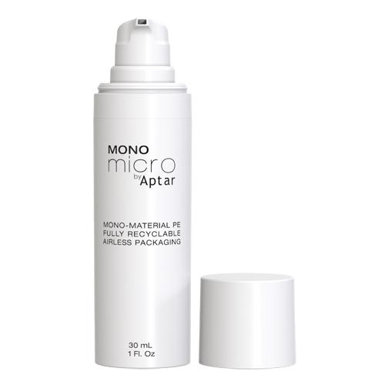

**Aptar** is presenting **Mono Micro**, the new airless dispenser in its Micro range. It is an approved mono-material solution with the cap, container, pump and cylinder all manufactured exclusively from PE. The packaging is fully recyclable and Cyclos Htp certified. In addition, the airless system can be emptied with very little residue, has 360° operation and provides optimum protection for the contents because the air no longer recirculates. Mono Micro is manufactured at the company's plant in Villingen, a town in southern Germany.

Web: [aptar.com](https://aptar.com)

**Corpack:**

**An Entire Product Portfolio Made from One Single Material**

Hall 3, Stand D02

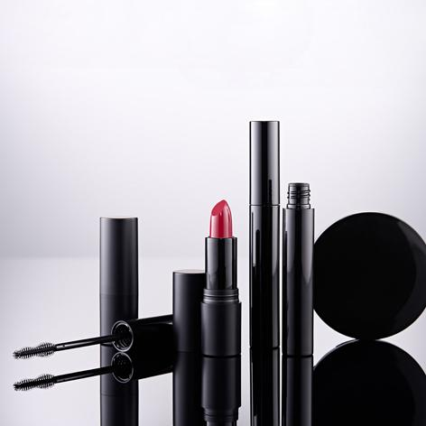

**Corpack** is bringing its **mono-material packaging** for lipstick, mascara and powder to Munich. All components are made exclusively from 100 per cent polypropylene (PP). This means the packaging manufacturer can support its customers in developing products that cater to consumer demand as well as meeting possible future packaging regulations. Packaging made from a single material is easier to separate and sort, which in turn leads to improved recyclability. High-quality recyclates can thus be fed back into the production chain, the company explains.

Web: [www.corpack.de](http://www.corpack.de/)

**EPL Europe:**

**All-in-One Low Weight and Mono-Material**

Hall 2, Stand C29

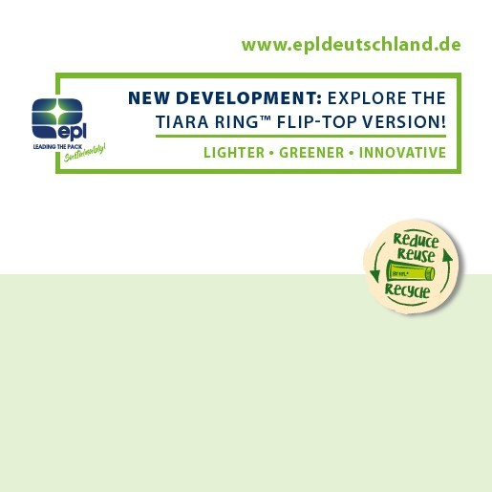

**EPL** is also presenting a mono-material solution at the trade fair. The manufacturer has combined the flip-top version of the **TIARA RING™** seal with its range of platina laminate products. The lightweight seal also uses less material, thus providing a cost-efficient and ecological solution, the company says. The flip-top seal without a shoulder can be printed seamlessly all the way around using 360° NEOSeam printing technology. EPL is currently focusing on a variant with a diameter of 50 mm. The exhibitor believes this is where the best weight savings can be achieved.

Web: [www.epldeutschland.de](http://www.epldeutschland.de/)

**KM Packaging:**

**PCR for Coloured Flip-Top Caps**

Hall 4, Stand A24

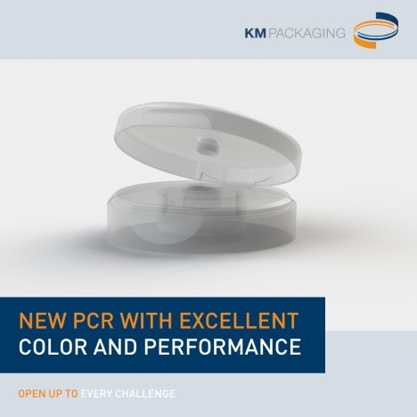

**KM Packaging** is investing in the use of recycled materials. The manufacturer is presenting its flip-top caps Tango and Melody Ultra that are already being made from PCR materials. KM uses a special type of highly transparent **PCR** material that allows caps to be produced in various colours. The PCR content of the caps is 70 per cent. According to the manufacturer, the material performance of the flip-top caps matches the quality of virgin plastics.

Web: [km-packaging.com](https://km-packaging.com)

**Lifocolor:**

**Transforming Plastics into Granite and Silver**

Hall 4, Stand F09

 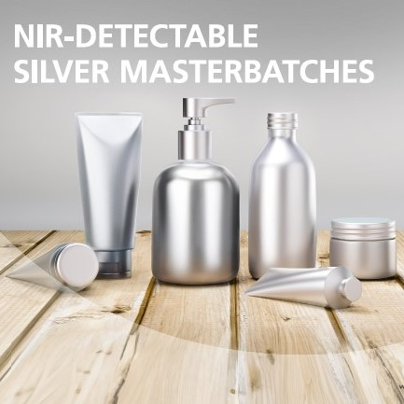

Masterbatch supplier **Lifocolor** is exhibiting two new colour effects from its portfolio. The masterbatches can create an authentic **granite effect** on PE, PP, ABS, PMMA and TPE. They are available in various shades and are compliant with EU and FDA food regulations, the company says. They can be used in injection moulding and extrusion processes with temperatures of up to 280 °C. Above all, Lifocolor hopes its new **silver and metallic masterbatches** can facilitate recycling-friendly design in cosmetics packaging. The silver colours can be correctly recognised using near-infrared light (NIR) in sorting systems and the packaging can subsequently be fed into the recycling process.

Web: [www.lifocolor.de](http://www.lifocolor.de/)

**Linhardt:**

**Next-Generation PCR Tubes**

Hall 4, Stand C08

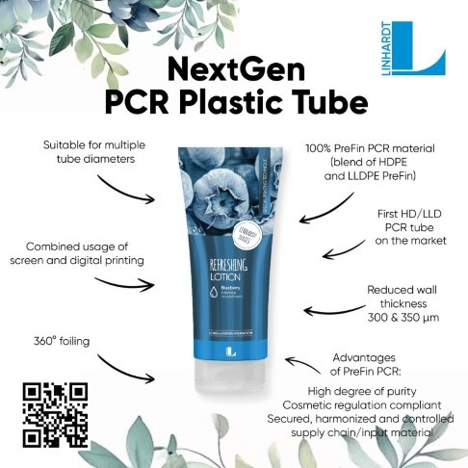

**Linhardt** sees itself as a pioneer in the use of PCR plastics in tubes. This year, the company is presenting its **NextGen PCR Plastic Tube**. It is said to be the first tube made from HD and LLD PCR. The tube features a mix of rigid and flexible PE made from 100 per cent PreFin PCR material that is suitable for cosmetics. This material has a high level of purity and is sourced from a safe and controlled supply chain, the manufacturer explains. The tubes can be customised using both screen and digital printing or by adding a 360° foil covering.

Web: [linhardt.com](https://linhardt.com)

**Nissha:**

**Biobased Packaging Designs Are as Diverse as Nature Itself**

Hall 4, Stand D01

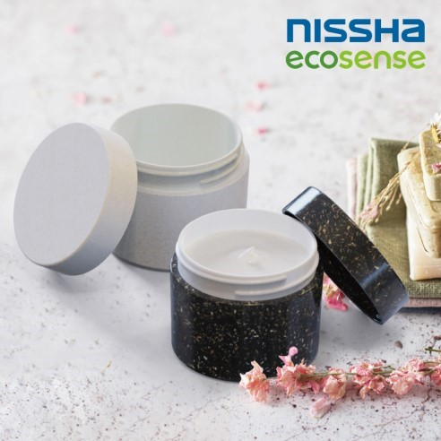

Japanese company **Nissha** is exhibiting a new **50 ml round jar** for water-based cosmetics. The container is produced using the biobased and industrially composted material Sulapac®. It is available in various colours and a variety of materials, each of which is based on a different natural material. This ensures the look and feel of each brand design can be adapted accordingly. The manufacturer gives examples, saying that a natural look with visible wood shavings conveys a message of natural cosmetics, whereas a look based on clay gives consumers an impression of luxury.

Web: [www.nissha.com](http://www.coptis.com/)

**Quadpack:**

**Stick Content as a Brand Design Extension**

Hall 4, Stand C04

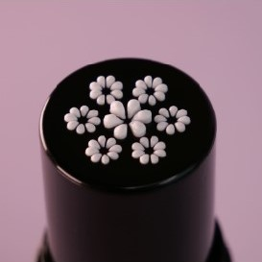

**Quadpack** is displaying its **ShapeUp Stick** at the trade fair. This innovative packaging design means that beauty products can be dispensed in a customised and pre-determined shape. A logo, emoticon or other graphic element is cut out of the stick material at the top end. The product dispensed through this opening then takes on the shape of the relevant iconic logo – a smiley or a rose, for instance. The stick can hold 12.5 ml of product. It is easy to refill, recyclable and made from the mono-material PP. According to the manufacturer, the cap and base are made from PCR PP.

Web: [www.quadpack.com](http://www.quadpack.com/)

**SeaMe:**

**New zerooo Multiple-Use Cosmetic Containers**

Hall 4, Stand F01.3

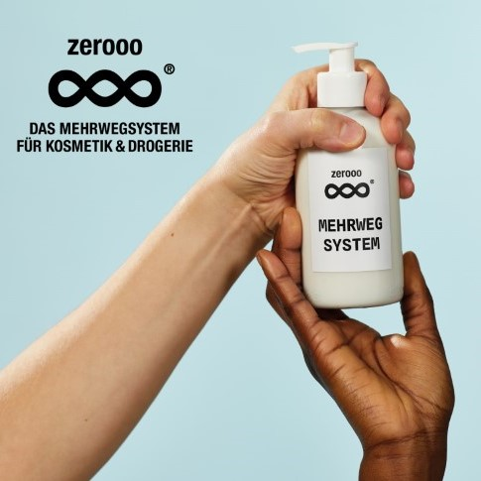

Start-up **SeaMe** is introducing its new PET mono-material bottle “**designed for reuse and recycle”**. It will be available from mid-2024 as part of the “**zerooo”** multiple-use system operated by the start-up for cosmetics and drug stores. Standardised containers from several brands are used in the closed pooling system. The young company says it hopes to prove that zero waste is possible in a mass market. The multiple-use system includes a return system for trading partners, a packaging return and cleaning service, as well as regular communication on various aspects such as life cycle assessment, serialisation & tracking (GRAI), and deposit handling.

Web: [sea-me.com](https://sea-me.com)

**Tianshi:**

**100 Per Cent Paper and No Air**

Hall 4, Stand D12

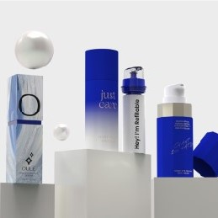

**Tianshi** is presenting its airless dispenser called **rebo Paper**. It is made entirely of paper. According to the manufacturer, it is suitable for a wide range of cosmetics, body care and pharmaceutical products. The concept is environmentally friendly and combines airless technology benefits such as high product protection and ease of operation with a customisable design. The company says the dispenser can be branded using hot foil and other embossing techniques. PCR cartridges can be used to refill it.

Web: [www.tianshiprint.com](http://www.tianshiprint.com)

**Tubex:**

**A Refillable Aluminium Tube**

Hall 4, Stand D15

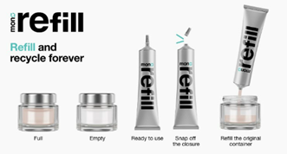

Packaging producer **Tubex** is showcasing its latest innovation called **MonoRefill**. The refill pack is made from 100 per cent recycled aluminium, 95 per cent of which is PCE material, the company says. The lightweight tube is easy to recycle. It is available in various sizes and is suitable for refilling perfume vials as well as different types of glasses and small bottles.

Web: [www.tubex-tube.com](https://www.tubex-tube.com/)

**About CosmeticBusiness**

CosmeticBusiness is the only international trade show in Europe where the cosmetics industry meets exclusively with its suppliers and finds solutions for the development of all cosmetic products, from active ingredients to manufacturing and packaging. As the only industry meeting place in Germany, the largest cosmetics market in Europe, the B2B trade show exhibition is a trend barometer for decision-makers from management, product management and development, marketing, as well as purchasing and production. The next edition of CosmeticBusiness will take place from 5 to 6 June 2024 at MOC Munich.

**About Leipziger Messe**

The Leipziger Messe is one of the ten leading German trade fair companies and one of the top 50 worldwide. It organises events in Leipzig and at various locations all over Germany and abroad. With its five subsidiaries and the Congress Center Leipzig (CCL), Leipziger Messe is a comprehensive service provider covering the entire chain of the events business. It is due to this level of professionalism, that customers and visitors in 2023 voted the Leipziger Messe the service champion of the trade fair industry in Germany's largest service ranking for the 10th time in a row. The Leipzig fairgrounds comprise an exhibition area of 111,900 m² and an open-air exhibition area of 70,000 m². Every year, over 270 events with over 15,300 exhibitors and more than 1.2 million visitors take place – from trade fairs, exhibitions and congresses to events. Leipzig was the first German trade fair company to be certified according to the Green Globe standards. Sustainability is a recurring theme in the Leipziger Messe's corporate activities.

**Press contact:**

Nicole Wege, Spokesperson CosmeticBusiness

Leipziger Messe GmbH

Phone:: +49 (0)341 / 678 6528

E-Mail: n.wege@leipziger-messe.de

<http://www.leipziger-messe.de>

**CosmeticBusiness on the Internet:** [www.cosmetic-business.com](https://www.cosmetic-business.com/en/)